LINUX MULTTHREADING

Multithreading - Printing Odd and Even Numbers Using Two Threads
- Write a C program using POSIX threads where one thread prints odd numbers and another thread prints even numbers up to 100, ensuring the output alternates correctly.
PROGRAM:
/*
Program to print odd and even numbers from 1 to 100 using mutex and condition variables.
Author : MUTHUGANESH S
Date : 11/03/2026
Filename : oe.c
*/

// Include necessary headers
#include <stdio.h>
#include <pthread.h>

// Declare mutex and condition variable
pthread_mutex_t lock;
pthread_cond_t cond;

// Global variable to track turn
int turn = 1; // 1 = odd thread, 0 = even thread

// Function to print odd numbers
void* print_odd(void* arg) {
for (int i = 1; i <= 100; i += 2) {
pthread_mutex_lock(&lock);

while (turn != 1)
pthread_cond_wait(&cond, &lock);

printf("%d ", i);

turn = 0;
pthread_cond_signal(&cond);

pthread_mutex_unlock(&lock);
}
return NULL;
}

// Function to print even numbers
void* print_even(void* arg) {
for (int i = 2; i <= 100; i += 2) {
pthread_mutex_lock(&lock);

while (turn != 0)
pthread_cond_wait(&cond, &lock);

printf("%d ", i);

turn = 1;
pthread_cond_signal(&cond);

pthread_mutex_unlock(&lock);
}
return NULL;
}

int main() {
pthread_t t1, t2;

pthread_mutex_init(&lock, NULL);
pthread_cond_init(&cond, NULL);

pthread_create(&t1, NULL, print_odd, NULL);
pthread_create(&t2, NULL, print_even, NULL);

pthread_join(t1, NULL);
pthread_join(t2, NULL);

pthread_mutex_destroy(&lock);
pthread_cond_destroy(&cond);

return 0;
}
OUTPUT:
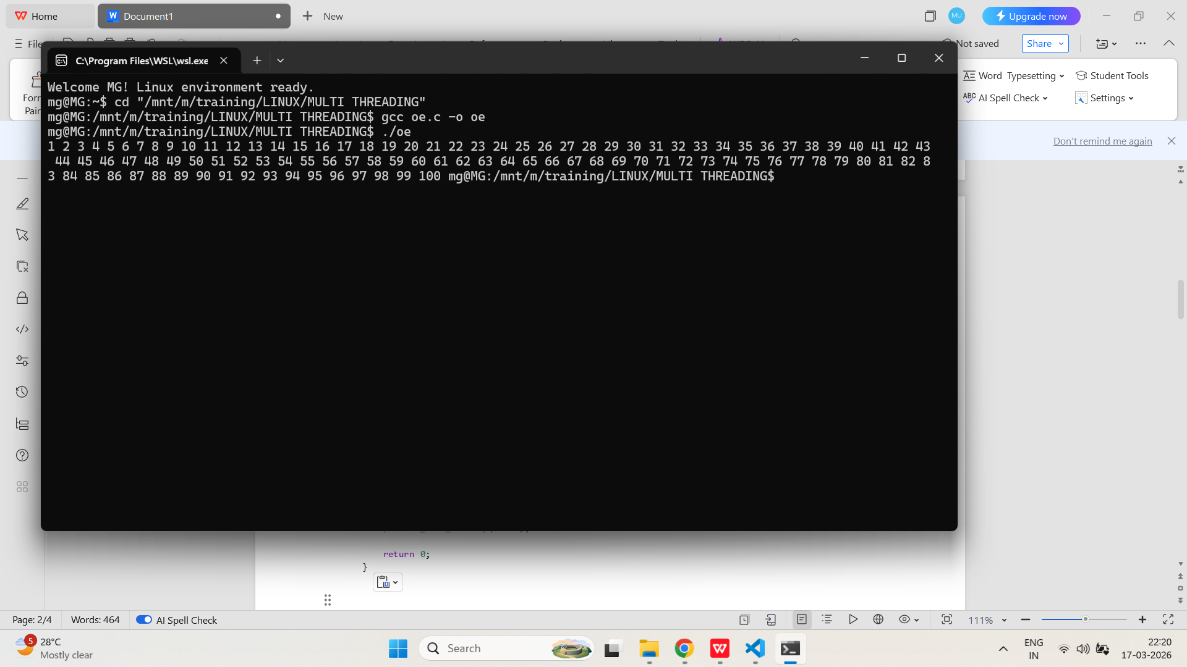

- Implement a program with two threads: one prints odd numbers and the other prints even numbers. Use synchronization primitives (mutexes or condition variables) to avoid race conditions and ensure correct sequence..
PROGRAM:
/*
Program to print odd and even numbers from 1 to 100 using mutex.
Author : MUTHUGANESH S
Date : 11/03/2026
Filename : ooe.c
*/

// This program creates two threads: one for printing odd numbers and another for printing even numbers.
#include <stdio.h>
#include <pthread.h>

// Mutex to synchronize access to the shared variable 'turn'.
pthread_mutex_t lock;
int turn = 1;

// Function to print odd numbers from 1 to 100.
void* print_odd(void* arg) {
for (int i = 1; i <= 100; i += 2) {
while (1) {
pthread_mutex_lock(&lock);

if (turn == 1) {
printf("%d ", i);
turn = 0;
pthread_mutex_unlock(&lock);
break;
}

pthread_mutex_unlock(&lock);
}
}
return NULL;
}

// Function to print even numbers from 1 to 100.
void* print_even(void* arg) {
for (int i = 2; i <= 100; i += 2) {
while (1) {
pthread_mutex_lock(&lock);

if (turn == 0) {
printf("%d ", i);
turn = 1;
pthread_mutex_unlock(&lock);
break;
}

pthread_mutex_unlock(&lock);
}
}
return NULL;
}

int main() {
pthread_t t1, t2;

pthread_mutex_init(&lock, NULL);

pthread_create(&t1, NULL, print_odd, NULL);
pthread_create(&t2, NULL, print_even, NULL);

pthread_join(t1, NULL);
pthread_join(t2, NULL);

pthread_mutex_destroy(&lock);

return 0;
}
OUTPUT:
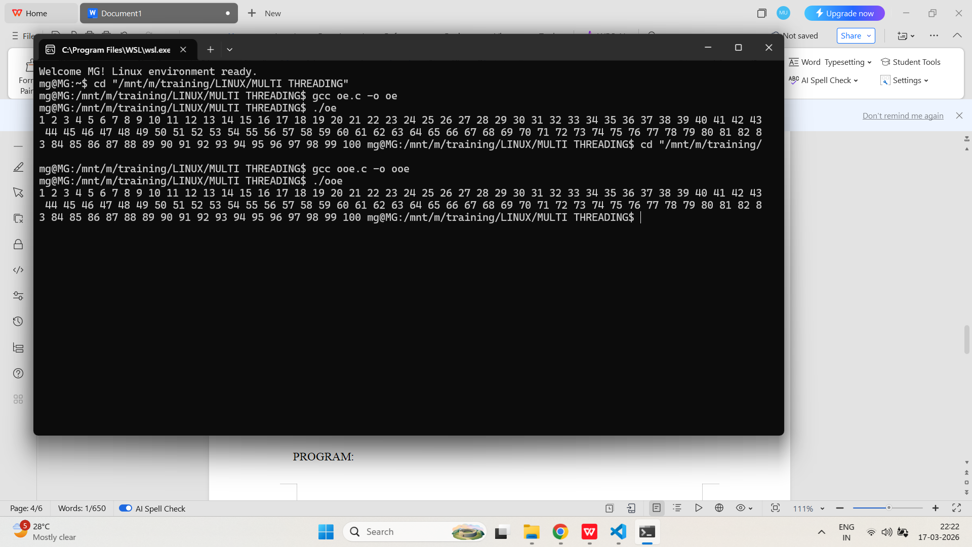
pthread_cancel
- Write a C program that creates a thread and cancels it from the main thread using pthread_cancel(). Demonstrate how the thread responds to cancellation.
PROGRAM:
/*
Program to demonstrate thread cancellation
Author : MUTHUGANESH S
Date : 11/03/2026
Filename : can.c
*/

#include <stdio.h>
#include <pthread.h>
#include <unistd.h>

void* worker(void* arg) {
while (1) {
printf("Worker thread running...\n");
sleep(1); // cancellation point
}
return NULL;
}

int main() {
pthread_t tid;

pthread_create(&tid, NULL, worker, NULL);

sleep(3); // let thread run

printf("Main thread: Cancelling worker...\n");
pthread_cancel(tid);

void* status;
pthread_join(tid, &status);

if (status == PTHREAD_CANCELED)
printf("Worker thread was cancelled successfully.\n");
else
printf("Worker thread exited normally.\n");

return 0;
}
OUTPUT:
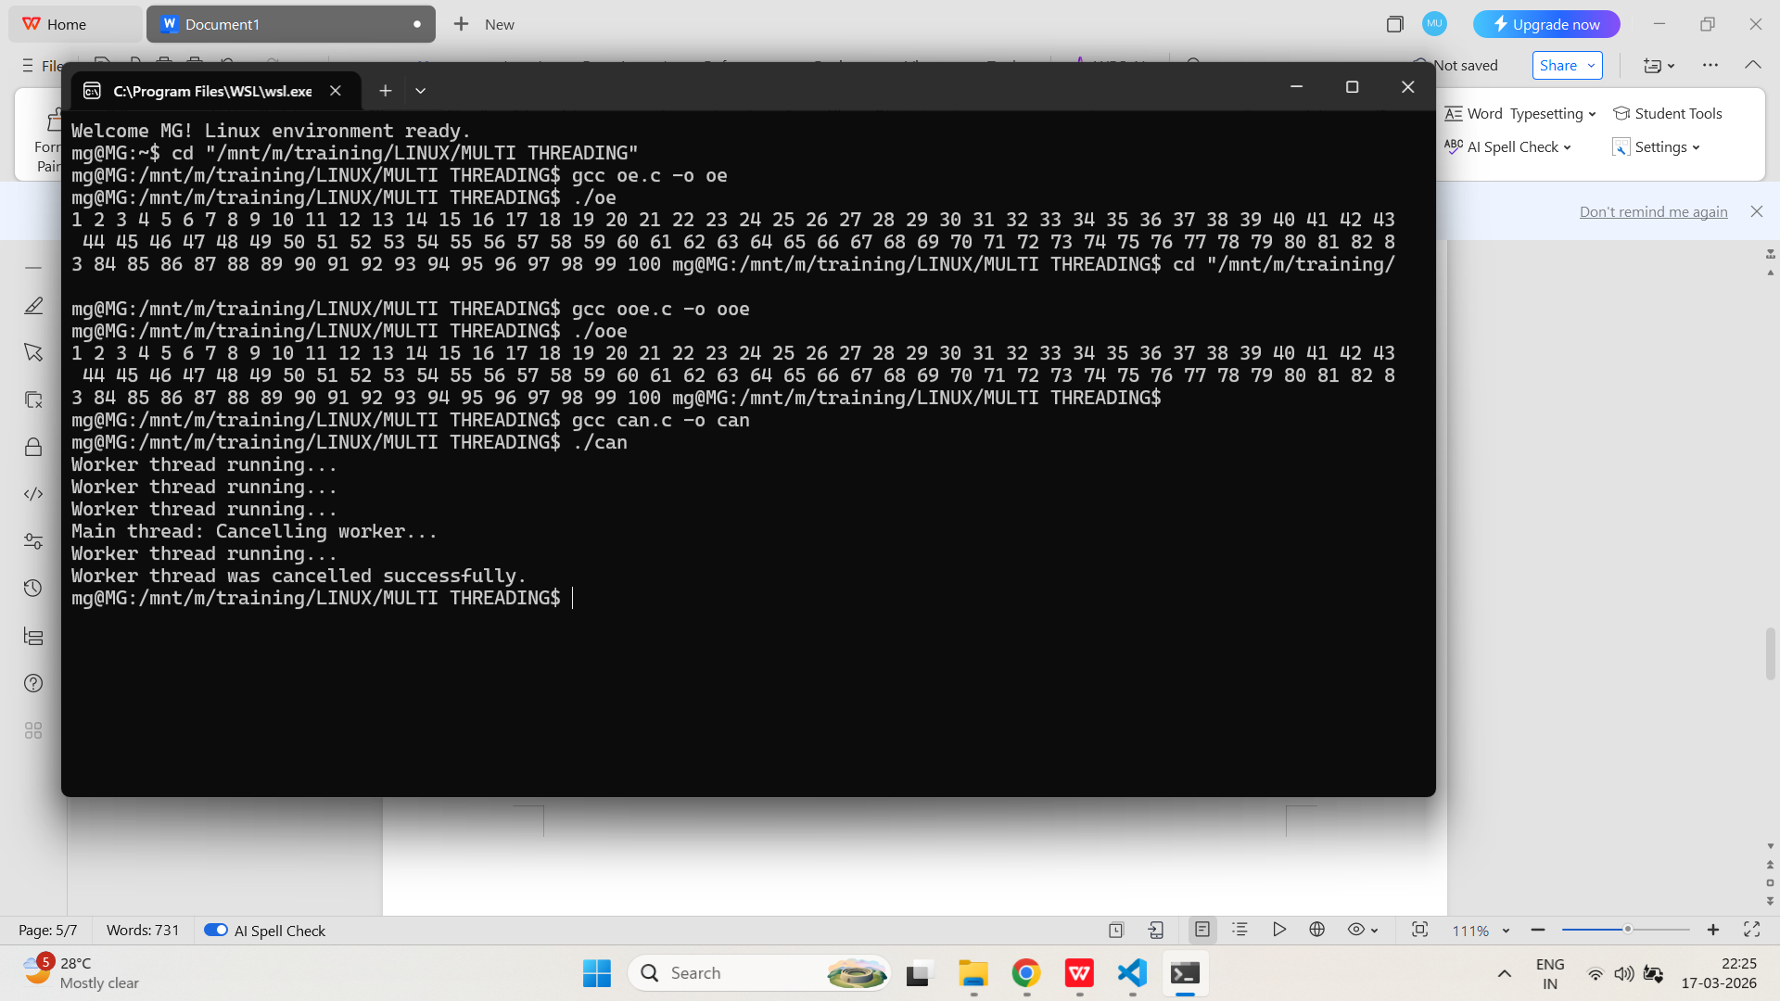

- Implement a program where a worker thread performs a long computation. The main thread cancels the worker after a timeout and checks the cancellation status.
PROGRAM:
/*
Program to demonstrate controlled thread cancellation
Author : MUTHUGANESH S
Date : 11/03/2026
Filename : con.c
*/

#include <stdio.h>
#include <pthread.h>
#include <unistd.h>

// Worker thread function
void* worker(void* arg) {
long long i = 0;

while (1) {
i++;

// simulate heavy computation
if (i % 10000000 == 0) {
printf("Working... i = %lld\t", i);

// explicit cancellation point
pthread_testcancel();
}
}

return NULL;
}

int main() {
pthread_t tid;

pthread_create(&tid, NULL, worker, NULL);

sleep(2); // allow computation

printf("Main: Requesting cancellation...\n");
pthread_cancel(tid);

void* status;
pthread_join(tid, &status);

if (status == PTHREAD_CANCELED)
printf("Worker thread cancelled.\n");
else
printf("Worker exited normally.\n");

return 0;
}
OUTPUT:
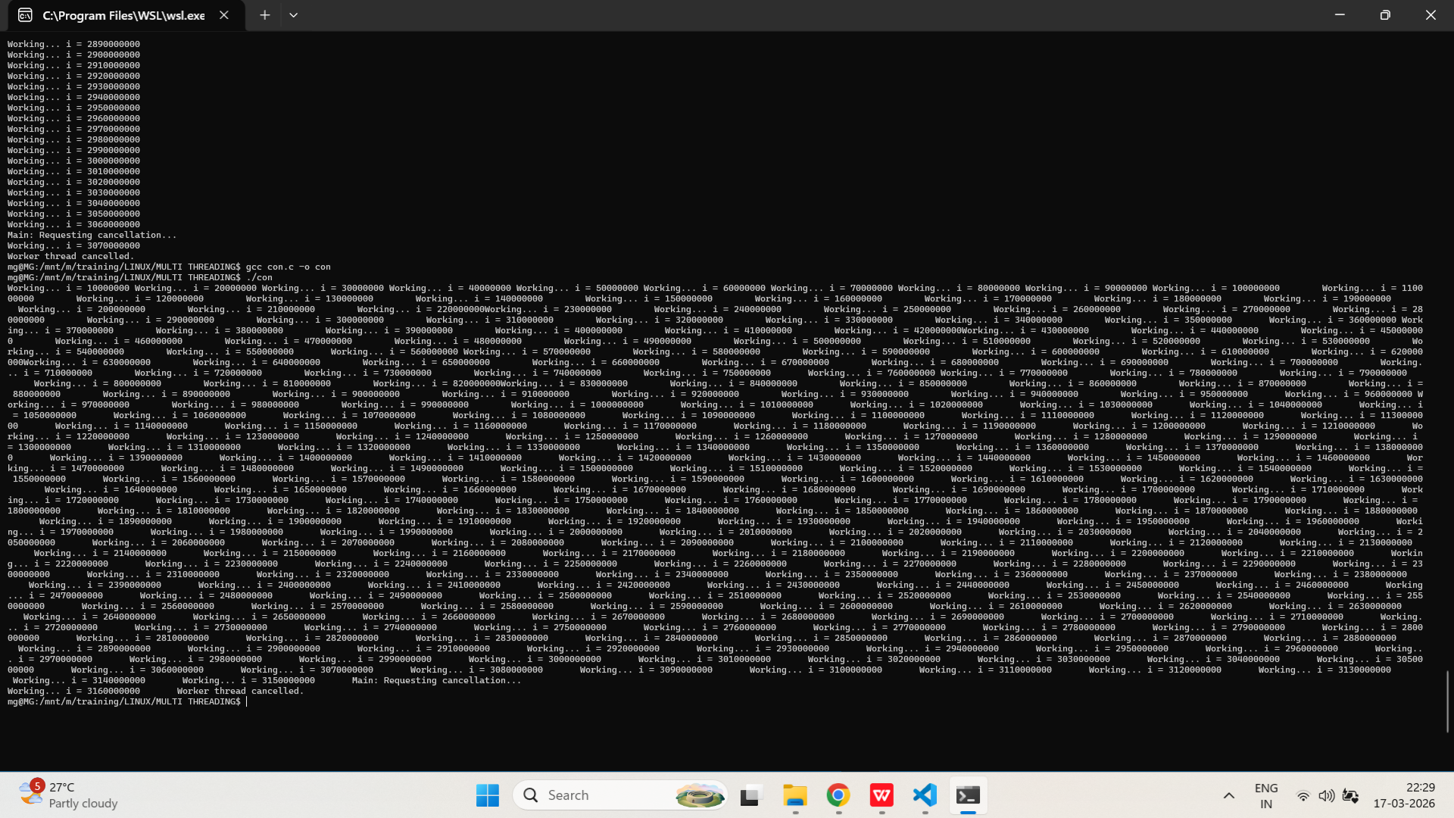

pthread_detach
- Write a C program that creates a thread and detaches it using pthread_detach(). Show what happens if the main thread exits before the detached thread finishes.
PROGRAM:
/*
Program to demonstrate the use of pthread_detach in C.
Author : MUTHUGANESH S
Date : 11/03/2026
Filename : det.c
*/

//Header files
#include <stdio.h>
#include <pthread.h>
#include <unistd.h>

// Worker thread function
void* worker(void* arg) {
for (int i = 1; i <= 5; i++) {
printf("Worker running: %d\n", i);
sleep(1);
}
printf("Worker finished\n");
return NULL;
}

int main() {
pthread_t tid;

pthread_create(&tid, NULL, worker, NULL);

pthread_detach(tid);

printf("Main thread exiting immediately...\n");

return 0;
}
OUTPUT:
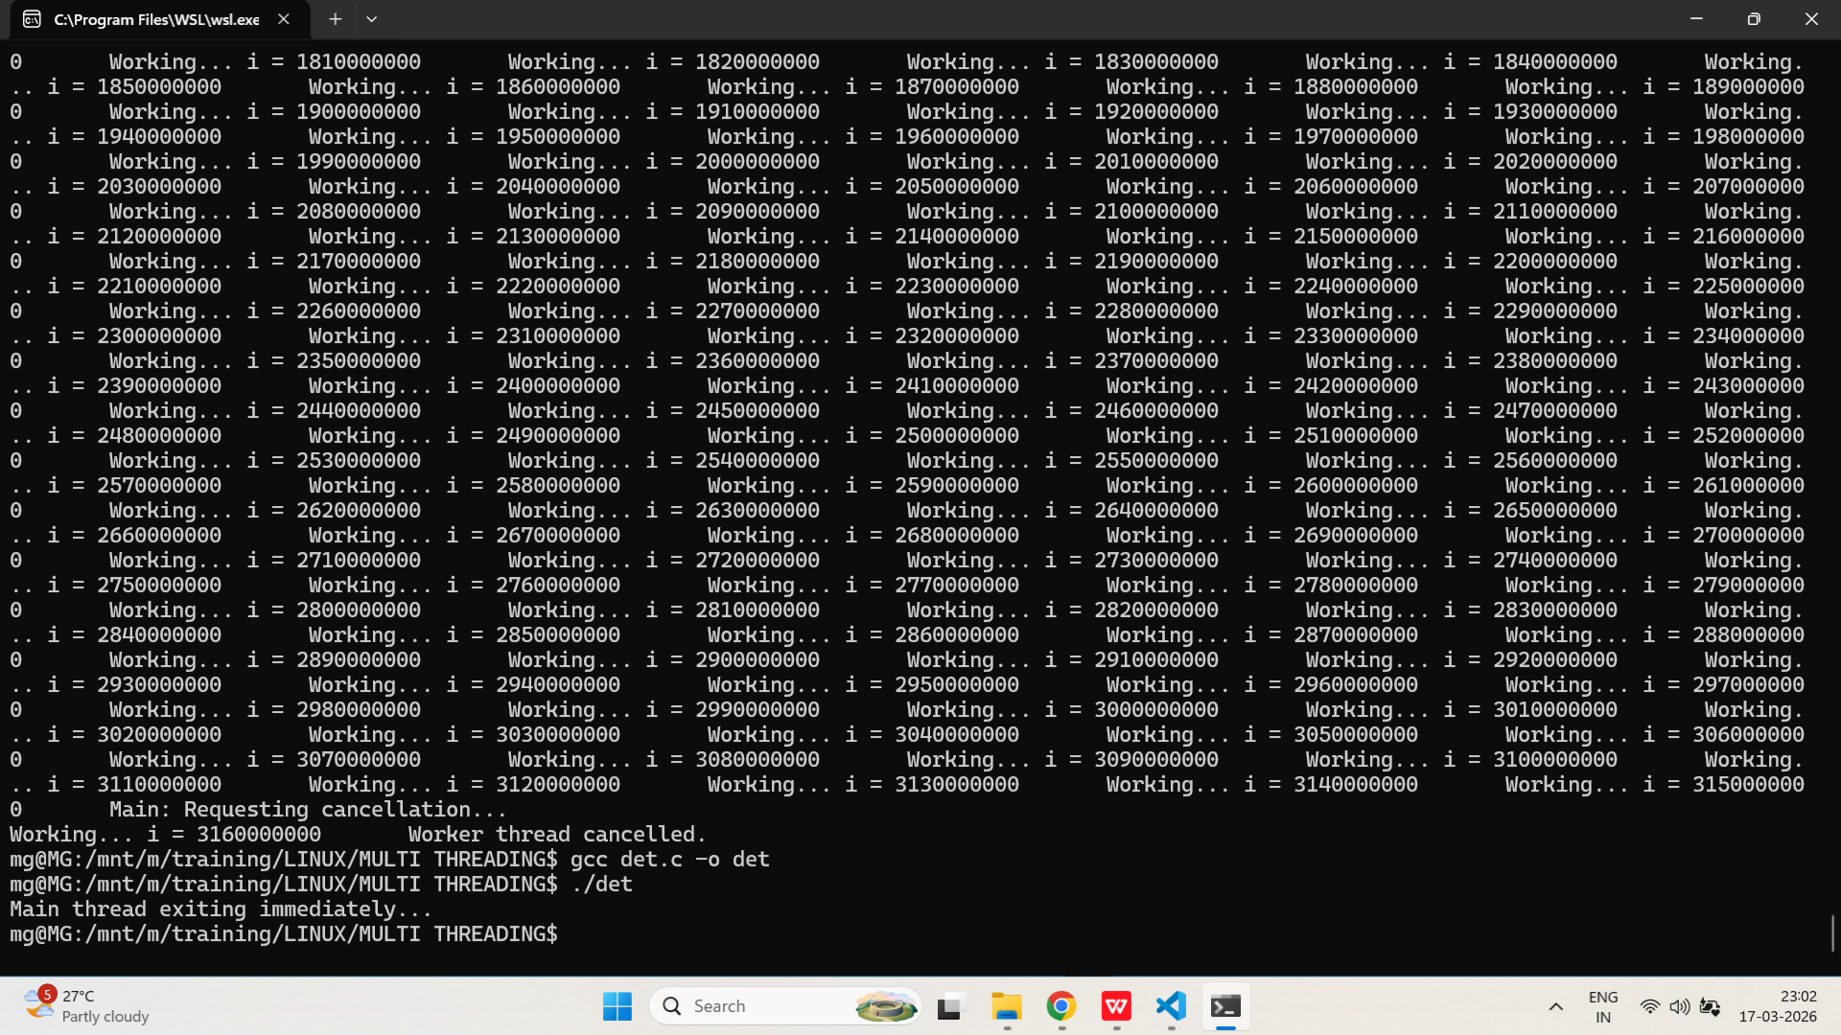
- Implement a program where multiple threads are created and detached. Demonstrate that their resources are automatically reclaimed upon termination.
PROGRAM:
/*
Program to demonstrate the use of pthread_join in C.
Author : MUTHUGANESH S
Date : 11/03/2026
Filename : join.c
*/

//Header files
#include <stdio.h>
#include <pthread.h>
#include <unistd.h>

// Number of threads to create
#define N 5

// Worker thread function
void* worker(void* arg) {
int id = *(int*)arg;
printf("Thread %d started\n", id);

sleep(2);

printf("Thread %d finished\n", id);
return NULL;
}

int main() {
pthread_t tid[N];
int ids[N];

for (int i = 0; i < N; i++) {
ids[i] = i + 1;

pthread_create(&tid[i], NULL, worker, &ids[i]);

pthread_detach(tid[i]); // detach immediately
}

printf("Main thread will not join threads\n");

// Keep process alive long enough
sleep(3);

printf("Main exiting\n");

return 0;
}
OUTPUT:
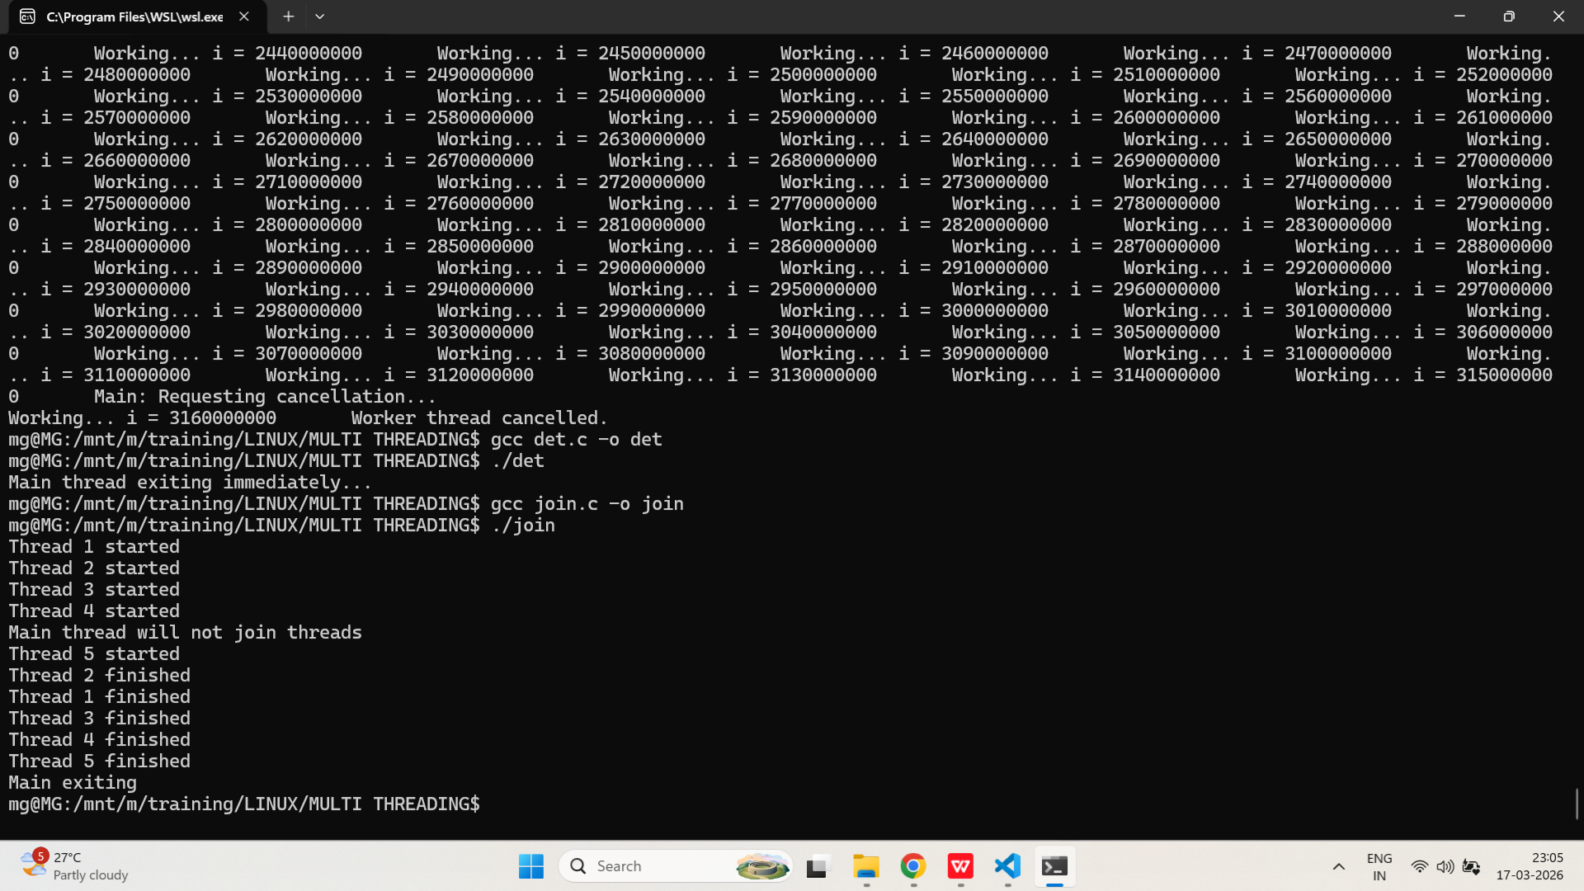
pthread_join
- Write a C program that creates several threads and uses pthread_join() to wait for each to finish, collecting their return values.
PROGRAM:
/*
Program to demonstrate multi join.
Author : MUTHUGANESH S
Date : 11/03/2026
Filename : mj.c
*/

// Header files
#include <stdio.h>
#include <pthread.h>
#include <stdlib.h>

// Number of threads to create
#define N 5

// Worker thread function
void* worker(void* arg) {
int id = *(int*)arg;

int* result = malloc(sizeof(int));
*result = id * id; // example computation

printf("Thread %d computed %d\n", id, *result);

return result;
}

int main() {
// Array to hold thread IDs and their corresponding arguments
pthread_t tid[N];
int ids[N];

for (int i = 0; i < N; i++) {
ids[i] = i + 1;
pthread_create(&tid[i], NULL, worker, &ids[i]);
}

for (int i = 0; i < N; i++) {
void* ret;
pthread_join(tid[i], &ret);

int* value = (int*)ret;
printf("Joined thread %d, result = %d\n", i + 1, *value);

free(value); // critical to avoid memory leak
}

return 0;
}
OUTPUT:
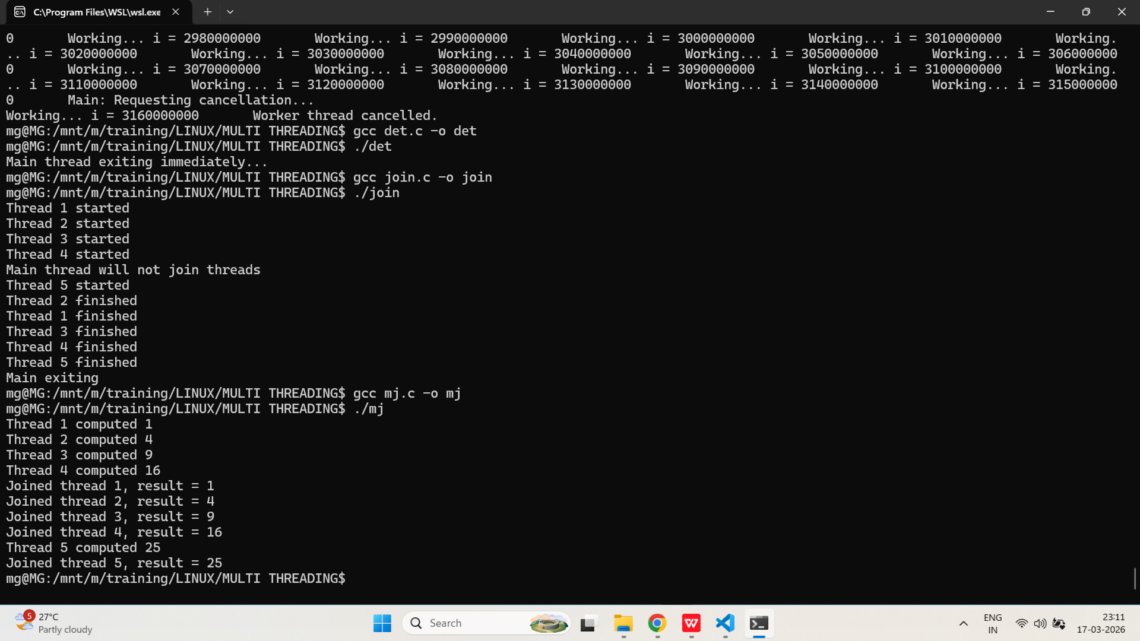

- Implement a program where the main thread waits for a worker thread to complete using pthread_join(), and prints the result returned by the worker.
PROGRAM:
/*
Program to show single thread returning a value to main thread using pthread_join() function.
Author : MUTHUGANESH S
Date : 11/03/2026
Filename : sj.c
*/

// Header files
#include <stdio.h>
#include <pthread.h>
#include <stdlib.h>

// Worker thread function
void* worker(void* arg) {
// Cast the argument to an integer pointer and dereference it
int n = *(int*)arg;

// Perform some computation (for demonstration, we'll just double the input)
int* result = malloc(sizeof(int));
*result = n * 2;

printf("Worker processed value\n");

return result;
}

int main() {
// Declare a thread ID and an input value for the worker thread
pthread_t tid;
int input = 10;

pthread_create(&tid, NULL, worker, &input);

void* ret;
pthread_join(tid, &ret);

int* value = (int*)ret;
printf("Result from thread = %d\n", *value);

free(value);

return 0;
}
OUTPUT:
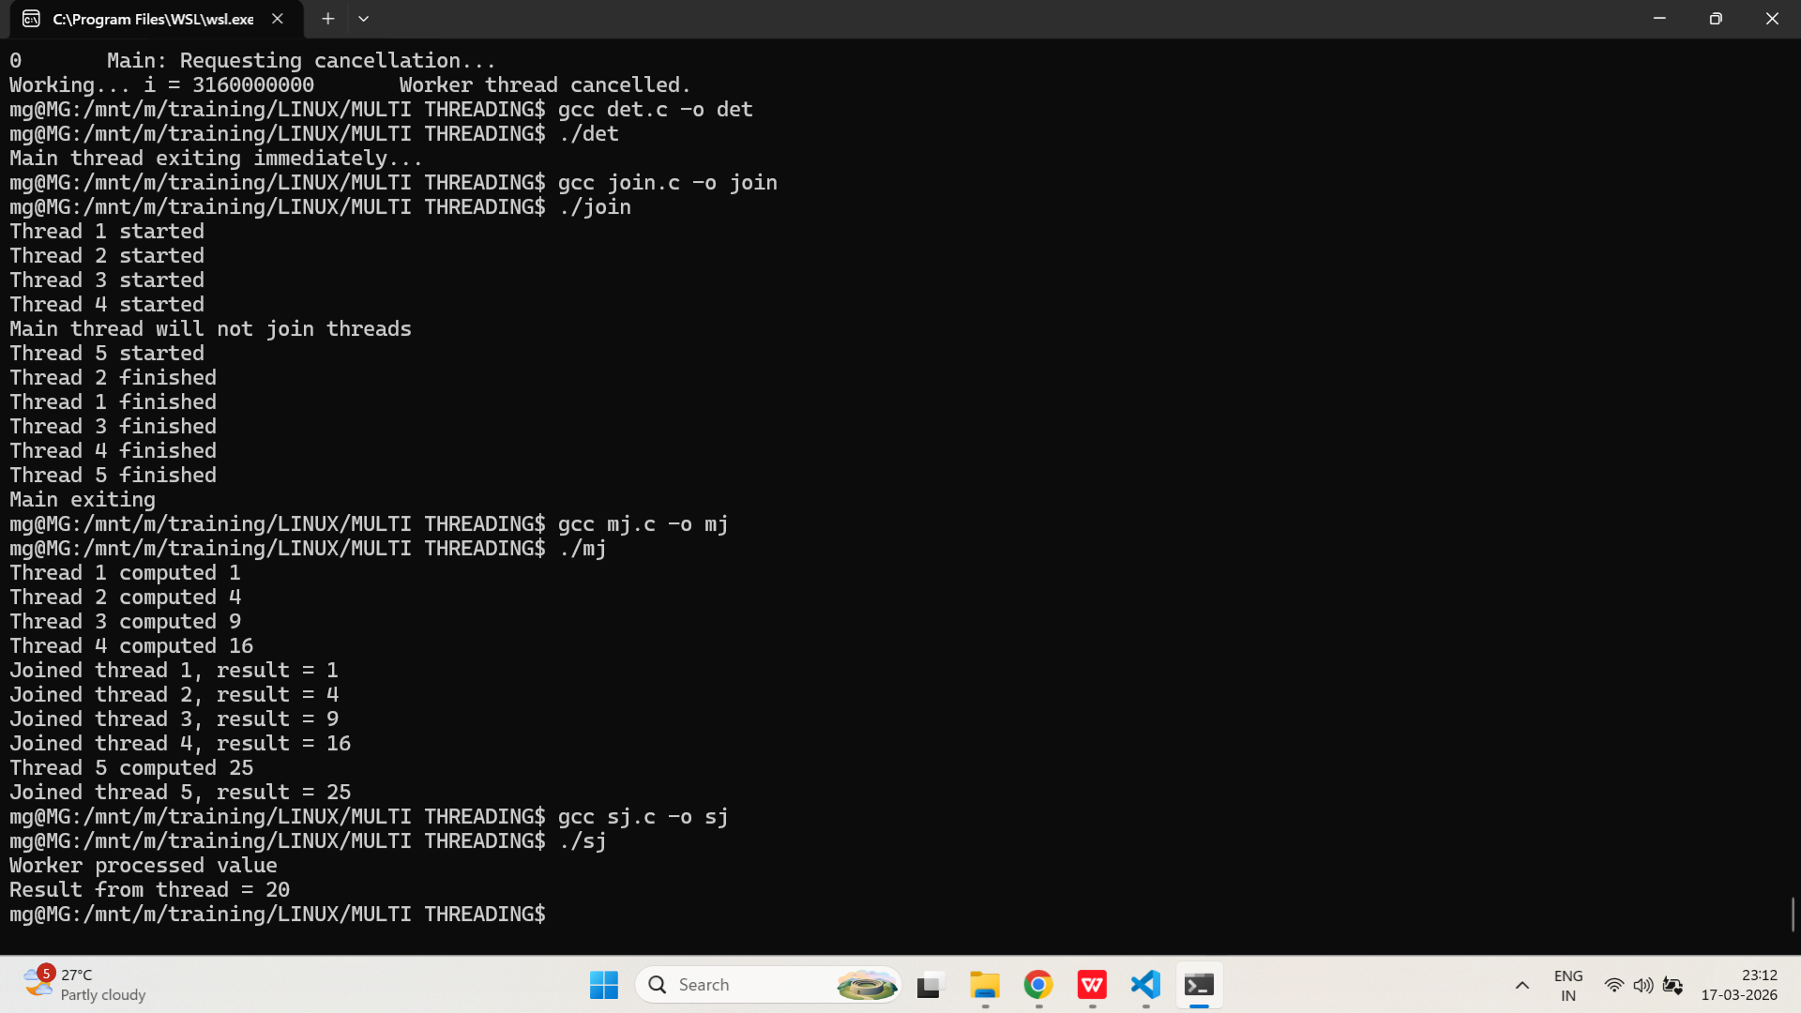
pthread_exit
- Write a C program where a worker thread uses pthread_exit() to return a value to the main thread. The main thread should retrieve and print this value using pthread_join().
PROGRAM:
/*
Program to demonstrate pthread_exit() and returning values from threads in C.
Author : MUTHUGANESH S
Date : 11/03/2026
Filename : exit.c
*/

// Header files
#include <stdio.h>
#include <pthread.h>
#include <stdlib.h>

// Worker thread function
void* worker(void* arg) {
int x = *(int*)arg;

int* result = malloc(sizeof(int));
if (!result) pthread_exit(NULL);

*result = x * 5;

printf("Worker computed: %d\n", *result);

pthread_exit(result);
}

int main() {
pthread_t tid;
int input = 7;

pthread_create(&tid, NULL, worker, &input);

void* ret;
pthread_join(tid, &ret);

if (ret != NULL) {
int* value = (int*)ret;
printf("Main received: %d\n", *value);
free(value);
} else {
printf("Worker returned NULL\n");
}

return 0;
}
OUTPUT:
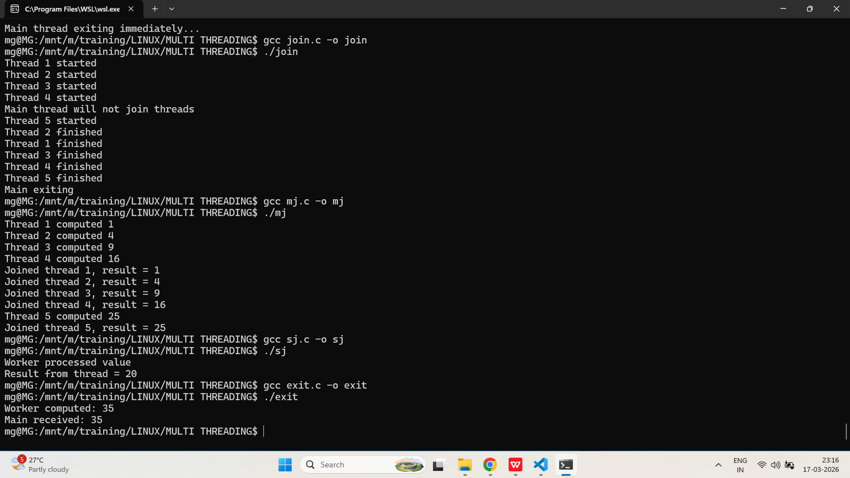
- Implement a program that creates multiple threads, each calling pthread_exit() with a different exit status. The main thread should collect and display the exit status of each thread.
PROGRAM:
/*
Program to demonstrate multi pthread_exit() and returning values from threads in C.
Author : MUTHUGANESH S
Date : 11/03/2026
Filename : multiexit.c
*/

// Header files
#include <stdio.h>
#include <pthread.h>
#include <stdlib.h>

// Number of threads to create
#define N 4

// Worker thread function
void* worker(void* arg) {
int id = *(int*)arg;

int* status = malloc(sizeof(int));
if (!status) pthread_exit(NULL);

*status = id * 10;

printf("Thread %d exiting with %d\n", id, *status);

pthread_exit(status);
}

int main() {
pthread_t tid[N];
int ids[N];

for (int i = 0; i < N; i++) {
ids[i] = i + 1;
pthread_create(&tid[i], NULL, worker, &ids[i]);
}

for (int i = 0; i < N; i++) {
void* ret;
pthread_join(tid[i], &ret);

if (ret != NULL) {
int* value = (int*)ret;
printf("Main collected from thread %d: %d\n", i + 1, *value);
free(value);
} else {
printf("Thread %d returned NULL\n", i + 1);
}
}

return 0;
}

OUTPUT:
